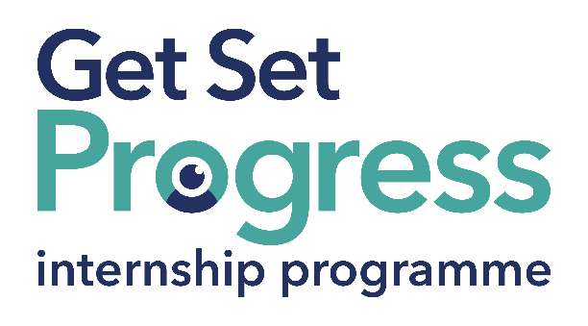

Communications and Administration Intern

Join us at Blatchington Court Trust
Thomas Pocklington Trust (TPT) and RNIB are collaborating with organisations from both the sight loss and wider charity sector as well as corporate organisations to create new opportunities for blind and partially sighted people to find employment through the Get Set Progress Internship programme. Blatchington Court Trust is delighted to be offering an internship as part of the Get Set Progress scheme.

Blatchington Court Trust (BCT) is a charitable incorporated organization supporting young people with sight loss throughout Sussex.

Our Values
We put our clients first: Our Clients and their families are at the centre of everything we do.
We listen, learn and share: Listening, informing and sign posting, sharing with each other what we’ve learnt.
We value each other: We value and respect the different ways people see the world.
We grow together: We are collaborative in our approach to the work we do.
We take pride: We take pride in what we do, and the people we work with.

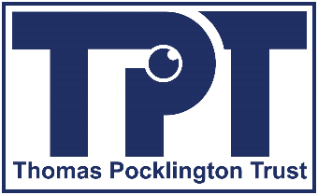

What are the benefits of a Get Set Progress internship for me?
As part of your 9-month internship, you will be part of a large cohort of fellow interns and gain the following:
- Obtain valuable work experience within the charity sector
- Technology support (Including Microsoft Office) and upskilling opportunities
- Online and in-person Training and development opportunities
- Opportunity to present and network with Senior leaders within the Sight Loss Sector
- Opportunities to build relationships with fellow interns
- A personal mentor offering support, advice and guidance throughout your internship
- Help deliver positive changes for people with sight loss

As part of the GSP Internship programme, you will also be enrolled on the TPT Works For Me Employment Programme, where you will gain bespoke employment support, guidance and advice from the TPT Employment Team, some of the skills that you will receive support and guidance around include:
- CV writing
- Job searching
- Cover letter and speculative letter writing
- Application form writing
- Interview techniques
The Works For Me team will also continue to support you in securing valuable employment after your time on the GSP internship programme has ended.

Job description

Role: Communications and Administration Intern
Department: Services (ICT and Administration)
Reporting to: Technical Services Manager
Location: Hybrid, BCT Office, Hove
Salary: Based on Living Wage Foundation rates (location dependent)
Contract type: Fixed Term 9 months, full-time 35 hours per week

Job Specification Information

Job purpose: Overview of the role:
To support the planning, delivery and upkeep of social media content and communication activity. To contribute to content creation such as blogs, podcasts, newsletters, welcome packs and wider external and internal communications activity across BCT. To provide administrative support throughout the process of grant applications, ordering and follow up services. To provide afternoon reception duties and any additional cover as and when required.

Key areas of responsibility:
- To support the running of BCT’s social media portfolio including Facebook, Twitter, Instagram.
- Creating accessible and engaging content about BCT’s work, using relevant internal and external communication channels.
- Preparation of resources including welcome/induction packs for clients and volunteers, and VI awareness training materials including PowerPoint presentations and handouts.
- Supporting clients through grant applications, arranging appointments to test equipment and/or training, purchase orders and follow up courtesy calls for feedback and after care.
- Annual courtesy calls to gain client database permissions and feedback.
- Researching the latest developments across the sight loss sector.
- Provide reception cover for afternoons and other times when the need arises so as to meet and greet visitors and answer incoming calls.
- Supporting at events outside of normal working hours may be required from time to time.

*This list of duties is an overview of the role; the list is not exhaustive and other ad hoc duties will be required.

Personal specification:
Essential criteria:
- This post has a Genuine Occupational Requirement that the successful applicant be a person who is blind or partially sighted, in line with The Equality Act 2010
- Interpersonal skills
- Good standard of verbal communication and written English
- A high attention to detail
- Experience in using social media in a personal or professional setting
- Knowledge of what makes good social media content
- Good standard of ICT skills across Microsoft Office
- Initiative
- Adaptability
- Teamwork
- Punctuality
- Willingness to travel to the TPT Hub in London for intern development events throughout the course of the internship programme
- Having not previously undertaken the Get Set Progress internship programme

Desirable Criteria:
- A good understanding of methods to ensure social media content is accessible to blind and partially sighted people

What to do next
If you are interested in this role email a CV and supporting statement explaining how you meet the person specification criteria to: paul@blatchingtoncourt.org.uk

For further information on this job role please contact Paul at BCT on: 01273 727222

Closing date:
11 December 2023

About Blatchington Court Trust:
BCT is a charitable incorporated organization who’s objective and aim is to support blind and partially sighted individuals to achieve lasting positive changes in their lives. For this reason, we are actively seeking applications from all backgrounds including disabled/blind and partially sighted individuals, and people who have lived experience of sight loss. We also guarantee all disabled applicants that reach the minimum appointment criteria an interview. We are happy to accept applications from all suitably qualified persons who have the appropriate skills and talent regardless of their age, gender, race, religion, disability, sexual orientation or marital status.

